## **Eatontown Complete Streets Technical Assistance - Conceptualization**

## **Kick-off Meeting and Site Visit**

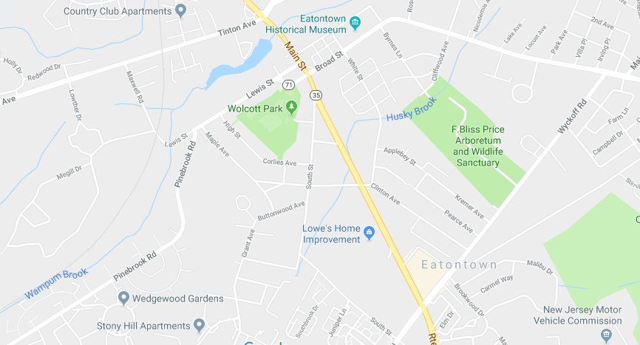Complete Streets Conceptualization:

The technical assistance team will work with the municipality to develop a series of before and after renderings of complete streets improvements and enhancements on a select number of streets and corridors in the municipality. The renderings will be based on accurate dimensions of streets and potential improvements.

Meeting location:

Borough Hall

47 Broad Street – 2nd Floor

Eatontown, NJ 07724

Date: Wednesday, January 23, 2019

Time: 1:00 pm – 3:30pm

Meeting participants:

Anthony Talerico Jr., Mayor, Borough of Eatontown

Candace Faust (chair), Representative from Eatontown Shade Tree Commission

Stephen Fratini (secretary), Representative from Eatontown Environmental Commission

Erik Brachman, Zoning / Planning Officer for Eatontown Borough

Janice Grasso, Director of Recreation for Eatontown Borough

James Sinclair, Voorhees Transportation Center at Rutgers University

Lisa Cintron, Voorhees Transportation Center at Rutgers University

Doug Greenfeld, North Jersey Transportation Planning Authority

Sutapa Bandyopadhyay, North Jersey Transportation Planning Authority

Anne Heasly, Sustainable Jersey

Purpose of the meeting:

•         Provide an opportunity for project participants to meet face-to-face

•         Discuss project team members and roles

•         Allow the technical assistance team to see first-hand and evaluate the locations for the conceptualizations

* Refine project scope and Timeline

Agenda:

1.       Introductions

2.       Brief overview of project scope

a.       Project context and background – information on local conditions and any information on previously completed projects completed for the area

b.       Discuss Community Engagement

c.       Methodology for the Development of Conceptualization Designs

d.       Final Report

3.       Time frame for project – late Jan 2019 – mid March 2019

4.       Tour project location

5.       Debrief

a.       Recap information gained from site visit

b.       Recap roles and responsibilities

c.       Discuss next steps and timeframes